Vizard practicum week 2 A.
Course: VR3d
Version: 1.3
Author: Michael Schifferling
Patrick de Beer (Unity add-on)

Introduction
In this practicum we are going to focus on different light sources and 3D object materials.

For Unity instructions go here.

Use the Vizard reference about light sources as a guideline . Open the help references section. Look at references->lights and references appearance & texturing->appearance and texturing command table.

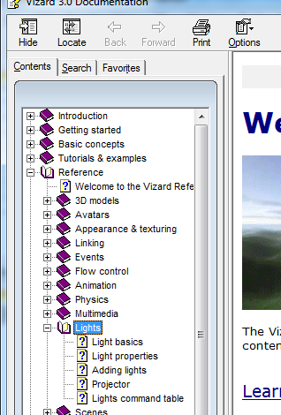
Also take a look at Tasks/Action Objects

Tutorials
Execute the following tutorials

Graphical user interfaces (GUIs)
GUI’s provide the means to give extra information to the user.

Tutorial: Action objects
This tutorial explains how you can easily animate an object.

Vizard Teacher in a Book
Read the following chapters:
- Modelling -> Lighting

Final assignment:
In this week’s final assignment lights and material are placed in the spotlight (pun might be intended). We also take a look at creating UI’s

Create a new Vizard project and add a few objects, preferably objects you created yourself with Wings3d. Of course you wouldn’t use the same objects as last week.
Now apply different materials to these objects.
Adhere to the following requirements:
- At least one object should have a shiny material
- One object should be visible even without lighting

Now add at least 3 lights to the scene (be aware that 8 is the maximum number of lights)
Note: Vizard always has 1 default light enabled. In order to see your own lights better, you can turn it off with the following code:
headLight = viz.MainView.getHeadLight()
headLight.disable()

Take notice of the following restrictions to the light sources:
- At least 1 light source should be directional
- At least 1 light source should be omni directional (point light)
- At least 1 light source should be a spot light
- All lights should have different colors
- At least 1 light should be animated (For example rotate around an object)

When you’ve implemented the above, there’s one more thing to do.
Add UI elements to change the parameters of one (or more) lightsources and material properties of 1 (or more) objects.
You can for example turn a light of with a checkbox, or use a slider to change the color of the material

Extra Final Assignment
In the scene that you create, try to add one of your geometric models from the last practicum (For example the cube or the sphere)
What do you see?

………………….…………………..…………………..………………….…………………..…………………..

………………….…………………..…………………..………………….…………………..…………………..

………………….…………………..…………………..………………….…………………..…………………..

………………….…………………..…………………..………………….…………………..…………………..

Unity practicum week 2a
In this week practicum you are going to learn how the different type of lights t can be programmed and how to assign material properties to 3d objects.
To make things a bit more interactive you will explore the GUI possibilities of Unity and add them to your scene so you are able to manipulate properties of your programmed lights.
Start by exploring the instructional links and studying the example scripts.

Final assignment
Create a new project and add a few objects, preferably objects you created yourself with Wings3d.
Of course you wouldn’t use the same objects as last week. Now apply different materials to these objects by using c# scripting.

Adhere to the following requirements:
- At least one object should have a shiny material
- One object should be visible even without lighting

Now add by using c# scripting at least 3 lights to the scene (to be able to see the effect of all 3 lights, it might be needed to check your project settings -> quality)

Take notice of the following restrictions to the light sources:
- At least 1 light source should be directional
- At least 1 light source should be omni directional (point light)
- At least 1 light source should be a spot light
- All lights should have different colors
- At least 1 light should be animated (For example rotate around an object)

When you have your materials and lights set-up the way you want, add some UI elements to change the parameters of one (or more) lightsources and material properties of 1 (or more) objects.

You can for example turn a light of with a checkbox, or use a slider to change the color of the material.

One last thing to check for today is to replace one of the objects in your scene now with your own procedural generated 3d objects. What do you see?

Bonus Assignment
Demonstrate how to script a simple character animation in Unity. The character animation might be a pre-fab. You can check this link to get started. http://lesterbanks.com/2014/05/playing-one-animations-object-character-unity/

Instructional links
How to switch on/off your lights: http://unity3d.com/learn/tutorials/modules/beginner/scripting/enabling-disabling-components
API for light programming:
http://docs.unity3d.com/ScriptReference/Light.html
API for defining materials:
http://docs.unity3d.com/ScriptReference/Material.html
GUI Basics:
http://docs.unity3d.com/Manual/gui-Basics.html

Useful Unity concepts in this practicum
Objects : Light , Material, GUI
methods: GetComponent<type>

